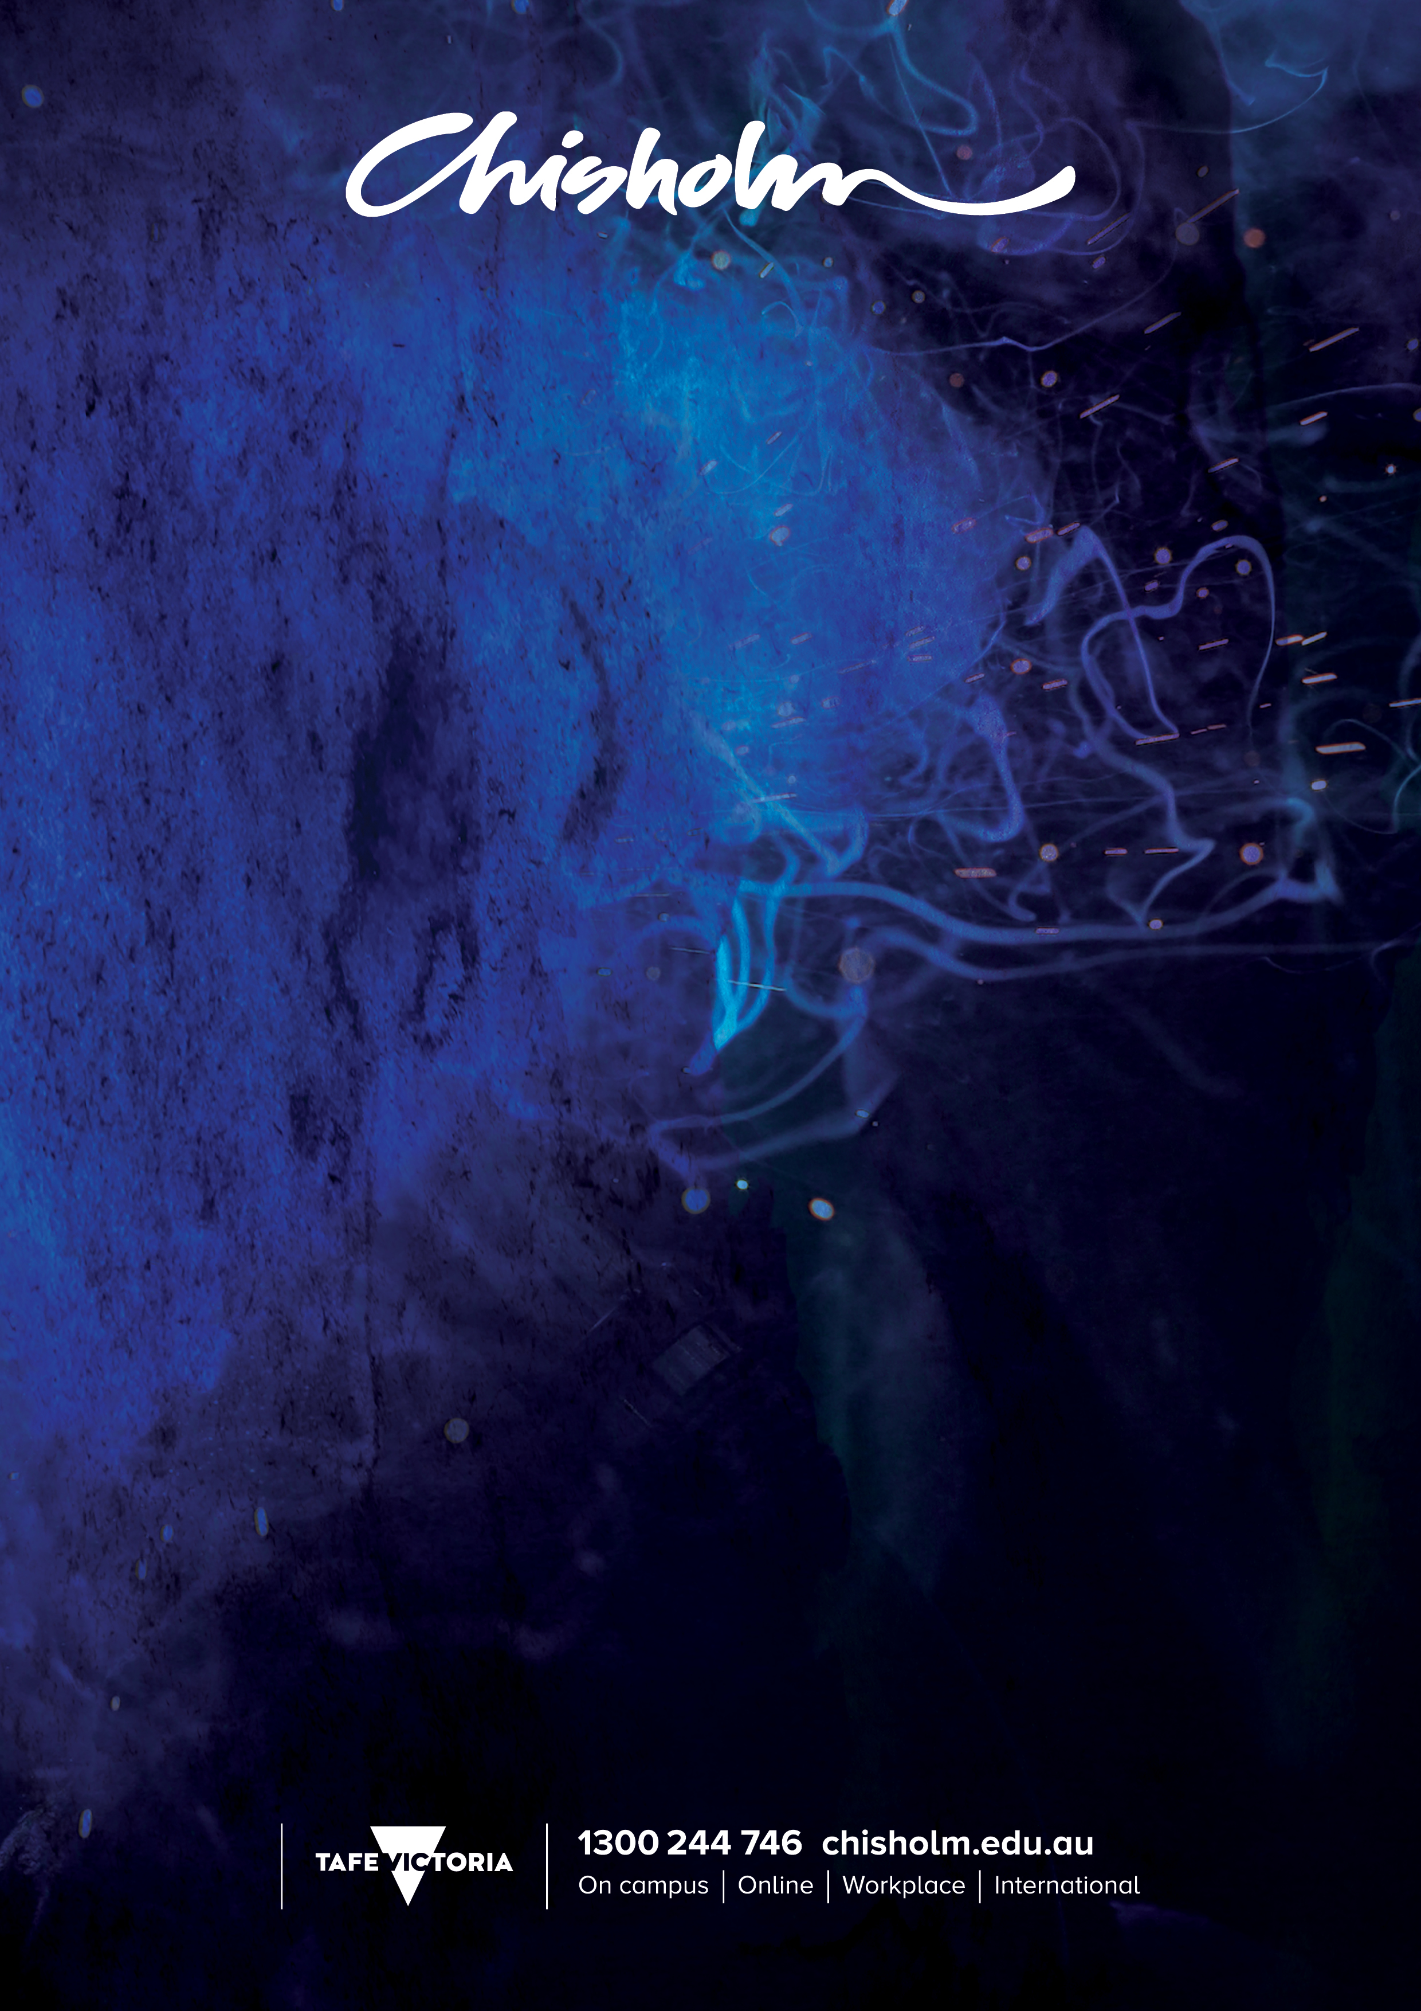

TRAVEL MANAGEMENT
SIT60116 Advanced Diploma of Travel and Tourism Management (Travel Management)
2016 QUALIFICATION

CORE UNITS OF COMPETENCY

BSBDIV501 | Manage diversity in the workplace
BSBMGT617 | Develop and implement a business plan
BSBRSK501 | Manage risk
BSBWRT401 | Write complex documents
SITTIND001 | Source and use information on the tourism and travel industry
SITTPPD008 | Develop tourism products
SITXCCS007 | Enhance the customer service experience
SITXCCS008 | Develop and manage quality customer service practice
SITXFIN002 | Interpret financial information
SITXFIN003 | Manage finances within a budget
SITXFIN004 | Prepare and monitor budgets
SITXGLC001 | Research and comply with regulatory requirements
SITXHRM003 | Lead and manage people
SITXMGT001 | Monitor work operations
SITXMGT002 | Establish and conduct business relationships
SITXMPR007 | Develop and implement marketing strategies
SITXWHS004 | Establish and maintain a work health and safety system
ELECTIVE UNITS OF COMPETENCY – Group A
SITTTSL002 | Access and interpret product information
SITTTSL005 | Sell tourism products and services
SITTTSL006 | Prepare quotations
SITTTSL008 | Book supplier services and products
SITTTSL009 | Process travel-related documentation
SITTTSL010 | Use a computerised reservations or operations system
ELECTIVE UNITS OF COMPETENCY – Additional required electives
SITXCOM002 | Show social and cultural sensitivity
SITTTSL001 | Operate an online information system
SITTPPD009 | Develop environmentally sustainable tourism operations
SITTPPD006 | Assess tourism opportunities for local communities

CRICOS No 00881F RTO No 0260. Training is deliver with Victorian and Commonwealth Government funding

