**NOTICE ON MATERIAL REPRODUCED OR COMMUNICATED UNDER STATUTORY TEXT AND ARTISTIC LICENCE**

**FORM OF NOTICE FOR PARAGRAPH 135ZXA(a) OF**

**COPYRIGHT ACT 1968**

**COMMONWEALTH OF AUSTRALIA**

**Copyright Regulations 1969**

**WARNING**

**This material has been reproduced and communicated to you by or on behalf of Chisholm Institute pursuant to Part VB of the Copyright Act 1968 (the Act).**

**The material in this communication may be subject to copyright under the Act. Any further reproduction or communication of this material by you may be the subject of copyright protection under the Act.**

**Do not remove this notice.**

**Maths Words**

These are common words that you may find when you complete the numeracy assessment:

|  |  |
| --- | --- |
| **Addition**  **Symbol:**  **Words:**  Add Increase  Plus More  And Sum  Total Together | **Subtraction**  **Symbol:**  **Words:**  Take away Less  Take from Reduce  Take Fewer  Minus Difference  How many more |
| **Multiplication**  **Symbol:**  **Words:**  Multiply Times  Product Multiplied by  Doubled Groups of | **Division**  **Symbol:**  **Words:**  Divided by Share  Divide Group  Divide into Share Equally  Each |

**Order of Operations**

**B – Brackets**

**O – Of / Orders**

**D – Division**

**M – Multiplication**

**A – Addition**

**S – Subtraction**

In maths, we must remember to always do the “groups of” and “sharing” parts first, before we add or subtract. We remember this with the acronym: BODMAS.

**BODMAS** reminds us to do *brackets* first,

Then any *multiplying or dividing*

And always do *adding and subtracting* last.

|  |
| --- |
| **More Information can be found on:**  **https://www.mathsisfun.com/operation-order-bodmas.html** |

**Rounding**

Rounding means making a number simpler but keeping its value close to what it was.

Accuracy is often not required. In many cases an approximate answer is all that’s needed.

When you use a calculator the answer can be more accurate than you need.

**For Example: $1.21 is closest to $1.20**

**$2.49 is closest to $2.50**

**$3.06 is closest to $3.05**

**Decimals**

## Adding decimals

## When adding decimal numbers, there are two important points to remember with the setting out:

**The decimal points MUST align with (be underneath) each other.**

**When adding, the bottom number must have the same amount of numbers after the decimal point as the top number. This is done by adding zeros as required.**

|  |  |  |  |
| --- | --- | --- | --- |
|  | **23.65** |  | **23.65** |
|  | **6.2** | *Change to* | **6.20** |
|  | **29.85** |  | **29.85** |

**‘Carrying’ a number**

|  |  |  |  |  |  |
| --- | --- | --- | --- | --- | --- |
|  |  | **1** |  |  |  |
|  | **1** | **8** | **=** | **12** |
| **+** |  | **4** |
|  |  | **2** |  |  |

All that is left to do is add together the numbers in the tens’ column now. Calculation. It would look like this:

|  |  |  |  |  |  |
| --- | --- | --- | --- | --- | --- |
|  |  | **1** |  |  |  |
|  | **1** | **8** | **=** | **22** |
| **+** |  | **4** |
|  | **2** | **2** |  |  |

More advanced addition problems with the addition of two digit plus two digit numbers with the need to carry are calculated by the very same method:

|  |  |  |  |  |  |
| --- | --- | --- | --- | --- | --- |
|  |  | **4** | **7** |  |  |
| **+** | **3** | **9** |

Carry the same way as above. Split up the number and write the units digit under the units’ column beneath the answer bar, and write the tens’ digit above the tens’ column in the addition problem.

|  |  |  |  |
| --- | --- | --- | --- |
|  |  | **1** |  |
|  | **4** | **7** |
| **+** | **3** | **9** |
|  |  | **6** |

Add the tens’ column together. There are three numbers in the tens’ column that you must add together, 1 + 4 + 3.

|  |  |  |  |
| --- | --- | --- | --- |
|  |  | **1** |  |
|  | **4** | **8** |
| **+** | **3** | **9** |
|  | **8** | **6** |

## 

|  |
| --- |
| **This information has been adapted from: “Building Strength With Numbers – Decimals. This is a free numeracy resource that can be obtained from:** http://www.valbec.org.au/building-strength-with-numeracy/ |

## Subtracting decimals

When subtracting decimal numbers, there are two important points to remember with the setting out:

**The decimal points MUST align with (be underneath) each other.**

**When subtracting, the top number must have the same amount of numbers after the decimal point as the bottom number. This is done by adding zeros as required.**

|  |  |  |  |  |
| --- | --- | --- | --- | --- |
|  | **29.3** | **-** | *Change to* | **29.300** |
|  | **19.325** |  |  | **19.325** |
|  | **9.975** |  |  | **9.975** |

**‘Borrowing’ a number**

In the unit column, we are trying to subtract 9 from 6.

In order to do this, there is a need to ‘borrow’ from the 2 (the number in the tens’ column). Borrowing only has a few steps, but they have to be done in the right order for the problem to work out.

|  |  |  |  |
| --- | --- | --- | --- |
|  |  | **2** | **6** |
| **_** |  | **9** |
|  |  |  |

E.g. cross out the digit in the tens’ column. In our example, it is a 2.

|  |  |  |  |
| --- | --- | --- | --- |
|  |  | **2** | **6** |
| **_** |  | **9** |
|  |  |  |

Above the number you just crossed out, write the number that is one less than the one you crossed out. For example, if you cross out a 3, write 2; if you cross out a 2, write 1, and so on. We are going to write our new number in red as well.

|  |  |  |  |
| --- | --- | --- | --- |
|  |  | **1** |  |
|  | **2** | **6** |
| **_** |  | **9** |
|  |  |  |

In front of the units digit, write a 1. This is actually making it a two digit number so the 6 becomes 16, 2 becomes 12, and so on. For our example, it started with 2, so we put a 1 (in red) in front of the 6 to make it 16.

|  |  |  |  |
| --- | --- | --- | --- |
|  |  | **1** |  |
|  | **2** | **16** |
| **_** |  | **9** |
|  |  |  |

Start your subtraction over again, starting with the units’ column. Your new subtraction problem is 16 – 9. We know that 16 – 9 = 7, so we write 7 in the units column in the answer.

|  |  |  |  |
| --- | --- | --- | --- |
|  |  | **1** |  |
|  | **2** | **16** |
| **_** |  | **9** |
|  |  | **7** |

Now it is possible to continue with the rest of the subtraction, which is in the tens’ column. Since there is only one digit in the tens’ column, the number can be brought straight down into the tens’ column of the answer.

|  |  |  |  |
| --- | --- | --- | --- |
|  |  | **1** |  |
|  | **2** | **16** |
| **_** |  | **9** |
|  | **1** | **7** |

**Subtracting two digit numbers**

A two digit subtraction problem looks like this:

|  |  |  |  |
| --- | --- | --- | --- |
|  |  | **7** | **4** |
| **_** | **3** | **8** |

In the units column we are trying to subtract 8 from 4 which cannot be done because 8 is bigger than 4. There is a need to go ‘borrow’ from the digit in the tens’ column, which is the 7 in this example.

|  |  |  |  |  |
| --- | --- | --- | --- | --- |
|  |  |  |  |  |
|  | **7** |  | **4** |
| **_** | **3** |  | **8** |
|  |  |  |  |

Cross out the 7 and write 6 above the crossed out number.

|  |  |  |  |
| --- | --- | --- | --- |
|  |  | **6** |  |
|  | **7** | **4** |
| **_** | **3** | **8** |
|  |  |  |

In front of the units’ digit, write a 1. You are actually making it a 2-digit number when you do this, so 4 becomes 14:

|  |  |  |  |  |
| --- | --- | --- | --- | --- |
|  |  |  | **6** |  |
|  |  | **7** | **14** |
| **_** |  | **3** | **8** |
|  |  |  |  |

Start your subtraction over again, starting with the units column. Your new subtraction problem is 14 – 8. We know that 14 – 8 = 6, so we write 6 in the units column in the answer.

|  |  |  |  |
| --- | --- | --- | --- |
|  |  | **6** |  |
|  | **7** | **14** |
| **_** | **3** | **8** |
|  |  | **6** |

Continue with the rest of the subtraction, which is in the tens’ column. This is where the step differs from before.

Previously, the number was just brought the top number straight down, because there was only one digit in the tens’ column. Now, there are two digits in the tens’ column, so we can subtract them. In the tens’ column, we have 6 – 3, which equals 3. Therefore enter a 3 in the tens’ column.

|  |  |  |  |
| --- | --- | --- | --- |
|  |  | **6** |  |
|  | **7** | **14** |
| **_** | **3** | **8** |
|  | **3** | **6** |

|  |
| --- |
| **This information has been adapted from: “Building Strength With Numbers – Decimals. This is a free numeracy resource that can be obtained from:** http://www.valbec.org.au/building-strength-with-numeracy/ |

## Multiplying decimals

**When multiplying decimals, it is easier to remove the decimal points, and then put the decimal point into the answer later.**

**When multiplying always count the number of decimal points that have been used in the calculation. Move the decimal point that many places to the left of the calculated answer**

**Step 1:** Multiply the numbers as if they were whole numbers, ignoring the decimal point.

**10.13 x 3.6 =**

|  |  |  |  |  |  |  |  |
| --- | --- | --- | --- | --- | --- | --- | --- |
|  |  | **1** | **0** | **1** | **3** | **x** |  |
|  |  |  |  | **3** | **6** |  |  |
|  |  | **6** | **0** | **7** | **8** | **+** | **1013 X 6** |
|  | **3** | **0** | **3** | **9** | **0** |  | **Move over one (1) space and multiply by three (3)** |
|  | **3** | **6** | **4** | **6** | **8** |  | **Add the two (2) responses together for the result** |

**Step 2:** Count the numbers after the decimal point in both numbers

3.6 has one number after the decimal place (.6)

10.13 has two numbers after the decimal place (.1 3)

Therefore you have to move the decimal place 3 places (1 + 2)

**Step 3:** Move the decimal point 3 places to the left in the result.

|  |  |
| --- | --- |
| **Answer:** |  |

## Multiplying decimals by 10, 100, 1000

**Numbers without decimal points are whole numbers. The decimal point is always after the whole number. For example, 6 can be written 6.0**

**To multiply**

To multiply a decimal by 10, 100 or 1000 we need to look at the number of zeros in the multiplier and move the decimal point to the right by that many places.



In the calculation above there is one zero in the number 10 so the decimal point is moved one place to the right.

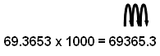

## Dividing decimals

Let’s try this calculation:

11.88 ÷ 36 without a calculator

**Step 1:** The **divisor** in this example is 36. The **dividend** is 11.88

|  |  |  |  |  |  |
| --- | --- | --- | --- | --- | --- |
|  | 36 | 1 | 1. | 8 | 8 |

**Step 2:** Divide the numbers as you would normally.

|  |  |  |
| --- | --- | --- |
| **11.88** | **÷** | **36** |
| **dividend** |  | **divisor** |

**Here is a step by step process:**

|  |  |  |
| --- | --- | --- |
| **The calculation** | **The activity** | **What happens** |
| |  |  |  |  |  | | --- | --- | --- | --- | --- | | 36 | 1 | 1. | 8 | 8 | | 1 ÷ 36 = 0 | The first digit of the dividend (1) is divided by the divisor. |
| |  |  |  |  |  |  | | --- | --- | --- | --- | --- | --- | |  | 0 |  |  |  |  | | 36 | 1 | 1. | 8 | 8 | |  | The whole number result is placed at the top. Any remainders are ignored at this point. |

|  |  |  |  |  |  |  |  |  |  |  |  |  |  |  |  |  |  |
| --- | --- | --- | --- | --- | --- | --- | --- | --- | --- | --- | --- | --- | --- | --- | --- | --- | --- |
| |  |  |  |  |  | | --- | --- | --- | --- | --- | |  | 0 |  |  |  | | 36 | 1 | 1. | 8 | 8 | |  | 0 |  |  |  | | 36 × 0 = 0 | The answer from the first operation is **multiplied** by the divisor. The result is placed under the number divided into. |
| |  |  |  |  |  | | --- | --- | --- | --- | --- | |  | 0 |  |  |  | | 36 | 1 | 1. | 8 | 8 | |  | 0 |  |  |  | |  | 1 |  |  |  | | 1 – 0 = 1 | Now we **subtract** the bottom number from the top number. |
| |  |  |  |  |  | | --- | --- | --- | --- | --- | |  | 0 |  |  |  | | 36 | 1 | 1. | 8 | 8 | |  | 0 |  |  |  | |  | 1 | 1 |  |  | | |  |  |  |  |  | | --- | --- | --- | --- | --- | |  | 0 |  |  |  | | 36 | 1 | 1. | 8 | 8 | |  | 0 |  |  |  | |  | 1 | 0 |  |  | | Bring down the next digit of the dividend. |
| |  |  |  |  |  | | --- | --- | --- | --- | --- | |  | 0 | 0 |  |  | | 36 | 1 | 1. | 8 | 8 | |  | 0 |  |  |  | |  | 1 | 1 |  |  | | 11 ÷ 36 = 0 | The whole number result is placed at the top. Any remainders are ignored at this point. |
| |  |  |  |  |  | | --- | --- | --- | --- | --- | |  | 0 | 0 |  |  | | 36 | 1 | 1. | 8 | 8 | |  | 0 |  |  |  | |  | 1 | 1 |  |  | | 36 × 00 = 0 | We can now **subtract** the bottom number from the top number. |
| |  |  |  |  |  | | --- | --- | --- | --- | --- | |  | 0 | 0 |  |  | | 36 | 1 | 1. | 8 | 8 | |  | 0 |  |  |  | |  | 1 | 1 | 8 |  | |  | Bring down the next digit of the dividend. |
| |  |  |  |  |  | | --- | --- | --- | --- | --- | |  | 0 | 0 |  |  | | 36 | 1 | 1. | 8 | 8 | |  | 0 |  |  |  | |  | 1 | 1 | 8 |  | | 118 ÷ 36 = 3 remainder | **Divide** this number by the divisor. |

|  |  |  |  |  |  |  |  |  |  |  |  |  |  |  |  |  |  |  |  |  |  |  |
| --- | --- | --- | --- | --- | --- | --- | --- | --- | --- | --- | --- | --- | --- | --- | --- | --- | --- | --- | --- | --- | --- | --- |
| |  |  |  |  |  | | --- | --- | --- | --- | --- | |  | 0 | 0 | 3 |  | | 36 | 1 | 1. | 8 | 8 | |  | 0 |  |  |  | |  | 1 | 1 | 8 |  | |  | The whole number result is placed at the top. Any remainders are ignored at this point. |
| |  |  |  |  |  |  | | --- | --- | --- | --- | --- | --- | |  | 0 | 0 | 3 |  |  | | 36 | 1 | 1. | 8 | 8 | |  | 0 |  |  |  |  | |  | 1 | 1 | 8 |  |  | |  | 1 | 0 | 8 |  |  | | 36 x 3 = 108 | The answer from the above operation is **multiplied** by the divisor. The result is placed under the last number divided into. |
| |  |  |  |  |  | | --- | --- | --- | --- | --- | |  | 0 | 0 | 3 |  | | 36 | 1 | 1. | 8 | 8 | |  | 0 |  |  |  | |  | 1 | 1 | 8 |  | |  | 1 | 0 | 8 |  | |  |  | 1 | 0 |  | | 118 - 108 = 10 | Now we **subtract** the bottom number from the top number. |
| |  |  |  |  |  | | --- | --- | --- | --- | --- | |  | 0 | 0 | 3 |  | | 36 | 1 | 1 | 8 | 8 | |  | 0 |  |  |  | |  | 1 | 1 | 8 |  | |  | 1 | 0 | 8 |  | |  |  | 1 | 0 | 8 | |  | Bring down the next digit of the dividend. |
| |  |  |  |  |  | | --- | --- | --- | --- | --- | |  | 0 | 0 | 3 |  | | 36 | 1 | 1. | 8 | 8 | |  | 0 |  |  |  | |  | 1 | 1 | 8 |  | |  | 1 | 0 | 8 |  | |  |  | 1 | 0 | 8 | | 108 ÷ 36 = 3 | **Divide** this number by the divisor. |
| |  |  |  |  |  | | --- | --- | --- | --- | --- | |  | 0 | 0 | 3 | 3 | | 36 | 1 | 1. | 8 | 8 | |  | 0 |  |  |  | |  | 1 | 1 | 8 |  | |  | 1 | 0 | 8 |  | |  |  | 1 | 0 | 8 | |  | The whole number result is placed at the top. Any remainders are ignored at this point. |

|  |  |  |  |  |  |  |  |  |  |  |  |  |  |  |  |  |  |  |  |  |  |  |  |  |  |  |  |  |  |  |  |  |  |  |  |  |  |
| --- | --- | --- | --- | --- | --- | --- | --- | --- | --- | --- | --- | --- | --- | --- | --- | --- | --- | --- | --- | --- | --- | --- | --- | --- | --- | --- | --- | --- | --- | --- | --- | --- | --- | --- | --- | --- | --- |
| |  |  |  |  |  | | --- | --- | --- | --- | --- | |  | 0 | 0 | 3 | 3 | | 36 | 1 | 1. | 8 | 8 | |  | 0 |  |  |  | |  | 1 | 1 | 8 |  | |  | 1 | 0 | 8 |  | |  |  | 1 | 0 | 8 | |  |  | 1 | 0 | 8 | | 36 x 3 = 108 | The answer from the above operation is **multiplied** by the divisor. The result is placed under the last number divided into. |
| |  |  |  |  |  | | --- | --- | --- | --- | --- | |  | 0 | 0. | 3 | 3 | | 36 | 1 | 1. | 8 | 8 | |  | 0 |  |  |  | |  | 1 | 1 | 8 |  | |  | 1 | 0 | 8 |  | |  |  | 1 | 0 | 8 | |  |  | 1 | 0 | 8 | |  |  |  |  | 0 | | 108 – 108 = 0 | Now we **subtract** the bottom number from the top number. |

**Step 3:** Put the decimal point in the quotient (answer) directly above the decimal point in the dividend.

|  |  |  |  |  |  |
| --- | --- | --- | --- | --- | --- |
|  | 0 | 0. | 3 | 3 | **Answer:** 0.33 |
| 36 | 1 | 1. | 8 | 8 |

**10.332 ÷ 36 =**

|  |  |  |
| --- | --- | --- |
| This can also be written as | 36 | 10.332 |

Divide the numbers as you would normally.

|  |  |  |  |  |  |
| --- | --- | --- | --- | --- | --- |
|  | 0 | 0 | 2. | 8 | 7 |
| 36 | 1 | 0 | 3. | 3 | 2 |
|  | 0 |  |  |  |  |
|  | 1 | 0 | 3 |  |  |
|  |  | 7 | 2 |  |  |
|  |  | 3 | 1 | 3 |  |
|  |  | 2 | 8 | 8 |  |
|  |  |  | 2 | 5 | 2 |
|  |  |  | 2 | 5 | 2  **Answer:** 2.87 |
|  |  |  |  |  | 0 |

## Dividing decimals by 10, 100, 1000

To divide a decimal by 10, 100 or 1000, the decimal point moves *to the left* by the same number of zeros.





At times there are not enough numbers to move the decimal point past so we need to add one or more zeros in front of the first number. This time your calculator would show a zero in front of the decimal point as well as adding one after the decimal point.

|  |
| --- |
| **This information has been adapted from: “Building Strength With Numbers – Decimals. This is a free numeracy resource that can be obtained from:** http://www.valbec.org.au/building-strength-with-numeracy/ |

**Percentages**

**The symbol tells us that we are dealing with a portion of 100.**

**Percent means ‘out of one hundred’.**

**The percentage of an amount is the number of small parts we have of the total of 100 parts.**

|  |  |  |  |
| --- | --- | --- | --- |
| 10% (10 out of 100) | | | |
|  |  | | |
| 50% (50 out of 100) | | | |
|  | |  | |
| 90% (90 out of 100) | | | |
|  | | |  |
| 100% (100 out of 100, the whole amount) | | | |
|  | | | |

1% means 1 out of 100 and is the same as , in other words to find 1% of an amount, divide by 100. For example: 1% of $500 is $500 ÷ 100 = $5.

**Calculating percentages**

**To calculate the *percentage of* an amount:**

1. **Divide the percentage by 100**
2. **Multiply this by the amount**

**For example: What is 30% of $200?**

**30 ÷ 100 x $200 = $60**

**Here are some examples:**

|  |  |  |
| --- | --- | --- |
| **Percentage** | **Amount of Money** | **Sum** |
| 30% | $200 | 30 ÷ 100 x 200 = |
| 45% | $200 | 45 ÷ 100 x 200 = |
| 35% | $200 | 35 ÷ 100 x 200 = |
| 60% | $200 | 60 ÷ 100 x 200 = |
| 50% | $500 | 50 ÷ 100 x 500 = |
| 25% | $500 | 25 ÷ 100 x 500 = |
| 75% | $500 | 75 ÷ 100 x 500 = |

**25% = one-quarter**

**(divide by 4)**

**50% = one-half**

**(divide by 2)**

**10% = one-tenth**

**(divide by 10)**

**Percentage Change**

Sometimes we need to work out what the percentage change (increase or decrease) is.

For example a shop has reduced the cost of a T-Shirt from $20 to $10

= 0.5 x 100

= 50%

**Percentages as ‘Parts of a Total’**

Sometimes you may have something that is a part of a larger amount and you need to know what percentage it represents.

1. **Divide the smaller part by the whole amount. You will end up with a decimal.**
2. **Multiply the decimal by 100 to get the percent.**

For example: I spend $20 per week on my phone and my total income is $400

1. 20 ÷ 400 = 0.05
2. 0.05 x 100 = 5%

I spent 5% of my income on my phone.

Here are some examples:

**Example 1:**

**10% of 456 is 45.6**

**10% of $14.25 is $1.43 (rounding up)**

**Example 2:**

**The price of a spanner is $6.**

**Today everything is 30% off.**

**What will today’s price be?**

**10% is $0.60**

**So 30% is 3 x 0.60 = 1.80**

**Price will be $6 - $1.80 = $4.20**

**Example 3:**

**For example: If Jayden earns $250 per week at the local fish and chip shop and he receives a 2% pay increase, how much will he now earn per week?**

**1% of $250 is $2.50**

**2% of $250 is $5.00 (twice as much)**

**So, he will now earn: $255 per week**

**Final Note:**

**If 10% is easy to find, you can find 20% by doubling it, or 5% by halving it, or 30% by multiplying it by 3. You could find 15% by adding 10% and 5%.**

|  |
| --- |
| **Source: Building Strength With Numeracy 2013 VALBEC** [**www.valbec.org.au**](http://www.valbec.org.au) **(adapted by: SandersD) http://www.valbec.org.au/building-strength-with-numeracy/**  http://www.valbec.org.au/building-strength-with-numeracy/ |

**Fractions**

**Fractions** are an equal part of a whole number. Fractions have a numerator (number on top) and a denominator (number on the bottom).

This is how to write a fraction:

**Numerator:** number of parts taken

Fraction bar

**Denominator:** number of equal parts the whole is broken into

|  |  |
| --- | --- |
|  |  |
|  |  |

The drawing shows

**Adding and Subtracting Fractions**

**To add or subtract fractions, they must have the same denominator.**

If they already have the same denominator, just add or subtract the numerators



|  |  |  |  |  |
| --- | --- | --- | --- | --- |
|  |  |  |  |  |



**Multiplying Fractions**

When multiplying fractions the following words are used: times, of, lots of.

**The rule for multiplying fractions is:**

* **Place the whole number over 1.**
* **Multiply the numerators and then multiply the denominators**

**Example:**

2 x 4 = 8

3 x 5 = 15



**More Information and activities to practise can be found on:**

**https://www.mathsisfun.com/fractions.html**

**Converting Fractions to Percentages**

**To convert a fraction to a percentage we must first convert the fraction to the decimal.**

**1. Divide the numerator by the denominator to find the decimal**

**2. Multiply the decimal by 100 to get the percentage.**

**More Information and activities to practise can be found on:**

**https://www.mathsisfun.com/fractions.html**

**Shapes**

**2-D Shapes**

In numeracy we call a shape that is *flat*: two dimensional.

If it is *flat*, it has *no* height or depth. So, it has only 2 dimensions: Length and width! It’s 2-D!!

Here are some examples of 2D shapes

**Search the internet for more 2D shapes: Use: *2D shapes* as your key words!**

**A polygon is any 2-dimensional shape formed with straight lines. Triangles, quadrilaterals, pentagons, and hexagons are all examples of polygons. The name tells you how many sides the shape has.**

**3-D Shapes**

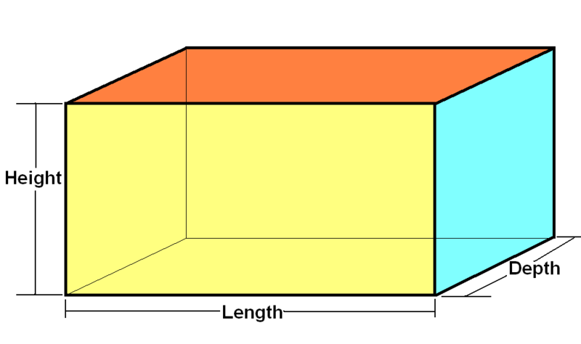Three dimensional shapes (3-D) have 3 dimensions:  **length, width** and **depth**.

We live in a 3-D world. Everything in our world has 3 dimensions.

**Search the internet for more 3d shapes: Use: *3D shapes* as your key words!**

**Shapes have: Faces, Vertices and Edges**

A vertex (plural: vertices) is a point where two or more lines meet. It is a Corner.

An edge is a line segment that join two vertices.

A face is any of the individual surfaces of a solid object.

**Euler's Formula**

**For many solid shapes the Number of Faces plus the Number of Vertices minus the Number of Edges always equals 2**

**This can be written: F + V − E = 2**

**More Information and activities to practise can be found on:**

**https://www.bbc.co.uk/education/guides/zj76fg8/revision**

**Measurement**

**Time**

**To convert 12-hour time to 24-hour time use this method:**

**From 1:00 PM to 11:59 PM you add 12 hours, and from 12:00 AM (midnight) to 12:59 AM you subtract 12 hours.**

**Search the internet for a table to show you 12 hour and 24 hour time: Use: *24 hour time* as your key words!**

**This link will take you to an online converter:**

**www.onlineconversion.com/date_12-24_hour.htm**

**Metric Units**

**The commonly used metric units of length include:**

* kilometres (Km)
* metres (m)
* centimetres (cm)
* millimetres (mm)

**The commonly used metric units of mass include:**

* gram (g)
* kilogram (kg)
* tonne (t)
* milligram (mg)

**The commonly used metric units of capacity include:**

* litre (l)
* millilitre (ml)
* cubic centimetre (CC)

**The table shows some of the most common units and their equivalents.**

|  |  |  |  |
| --- | --- | --- | --- |
| **Length** | 1 km = 1,000 m | 1 m = 100 cm | 1 cm = 10 mm |
| **Weight** | 1 tonne = 1000 kg | 1 kg = 1,000 g | 1 g = 1,000 mg |
| **Capacity** | 1 l = 100 cl | 1 cl = 10 ml | 1 l = 1,000 ml |

# **Converting larger units to smaller units**

**To convert a larger unit to a smaller unit (eg m to cm), first check the number of smaller units needed to make one larger unit. Then, multiply that number by the number of larger units.**

# **Converting smaller units to larger units**

**To convert a smaller unit to a larger unit (eg cm to m), divide it by the number of smaller units which are needed to make one larger unit.**

Converting between metric units of length is made easy because we only ever need to multiply or divide by **10, 100, 1000,** etc. to change to different units. This is done by simply moving the decimal point in the value being converted.

This shows the key information you need to convert between units of length.

|  |
| --- |
| 10mm = 1cm  100cm = 1m  1000m = 1km  http://www.mathsteacher.com.au/year8/ch11_perimeter/01_units/Image15290.gif |

***Examples: Converting Length***

|  |  |
| --- | --- |
| mm ÷ 10 = cm  25 mm ÷10 = 2.5 cm | cm x 10 = mm  4 cm x 10 = 40 mm |
| cm ÷100 = m  400 cm ÷100 = 4 m | m x 100 = cm  3.6 m x 100 = 360 cm |
| m ÷ 1000 = km  4800 m ÷ 1000 = 4.8 km | km x 1000 =m  6.6 km x 1000 = 6600 m |

***Converting between Grams and Kilograms***

1000g = 1kg

|  |  |
| --- | --- |
| g ÷ 1000 = kg  5100 g ÷ 1000 = 5.1 kg | kg x 1000 =g  6.5 kg x 1000 = 6500 g |

***Converting between Millilitres and Litres***

1000mL = 1L

|  |  |
| --- | --- |
| mL ÷ 1000 = L  2000 mL ÷ 1000 = 2 L | L x 1000 =mL  1.5 L x 1000 = 1500 mL |

**Here are some examples:**

**Km 1000 m 100 cm 10 mm**

**Move the decimal point in the direction of the unit you want to convert to.**

**Example 1.**



175 *mm* = *cm*

Going from mm to cm, we must move decimal point one place

to the LEFT.

175 *mm* = 17.5 *cm*

**Example 2.**

2.3 *m* = *cm*

Going from m to cm, we must move decimal point two places

to the RIGHT

2.3 *m* = 230 *cm*

**Example 3.**

2075 *mm* = *cm*



Going from mm to m, we must move the decimal point three places

to the LEFT.

2 0 7 5 *mm* = 2.075 *cm*

(Created R McKenzie – Foundation College 2015)

**More Information and activities to practise can be found on:**

**https://www.bbc.co.uk/education/guides/zthsgk7/revision/3**

**Area and perimeter**

Perimeter is the total distance around a shape which has straight sides.

**Perimeter – Add all sides of the shape**

For example the perimeter of this shape is:

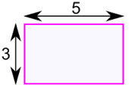

5 + 3 + 5 + 3 = 16

Area is number of unit squares that can be contained within a shape

**Area – The formula is:**

**Area = w × h  
w = width  
h = height**

For example the area of this shape is:



The width is 5, and the height is 3, so we know **w = 5** and **h = 3**: Area = 5 × 3 = **15**

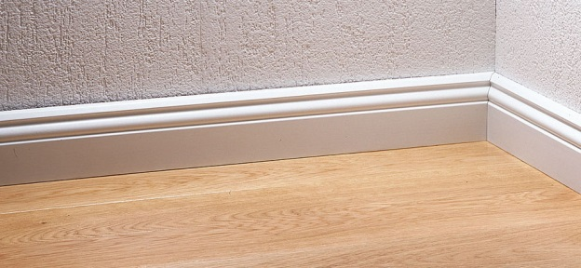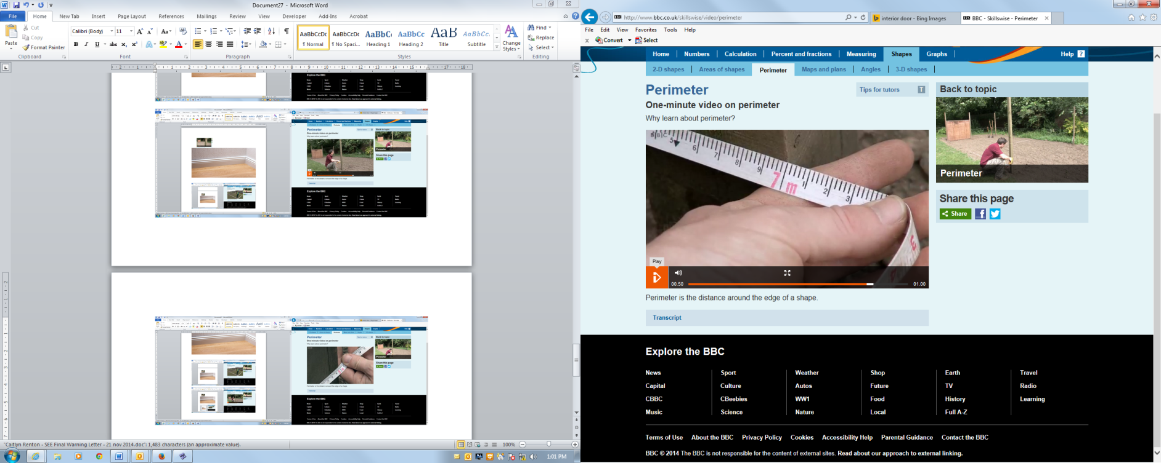**Capacity and Volume**

We use the term capacity when talking about the measure of how much space there is available to hold something.

For example the capacity of:

a jug  
a teacup or mug  
a food container  
a petrol tank

**Capacity is the amount a container can hold.**

**Volume** is something slightly different.

Here's an example:

A jug of juice has a capacity of 500 ml.   
  
The **volume** of juice is how much is actually in the jug  
  
The**volume** of juice needed to fill the jug is 500 ml.

**Volume is a measure of the space taken up by something.**

**This website provides many examples showing how to calculate volume of various shapes: https://www.helpingwithmath.com/by_subject/geometry/geo_volume.htm**

**Angles - Measuring angles between 0© and 180©**

**How many degrees is each angle?**

**This is 90 degrees**

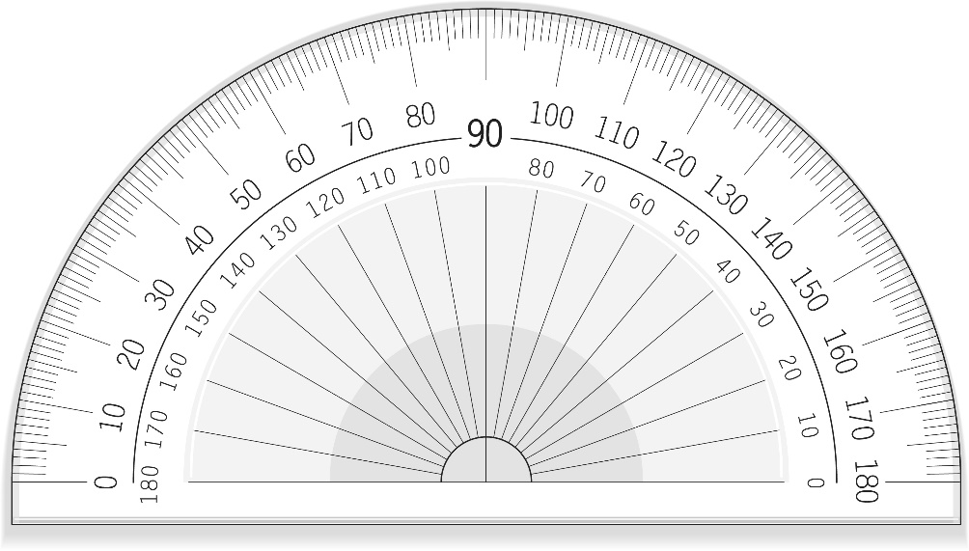

**Always read from zero,**

**not 180.**

(shutterstock_146377604)

**This is 60 degrees**

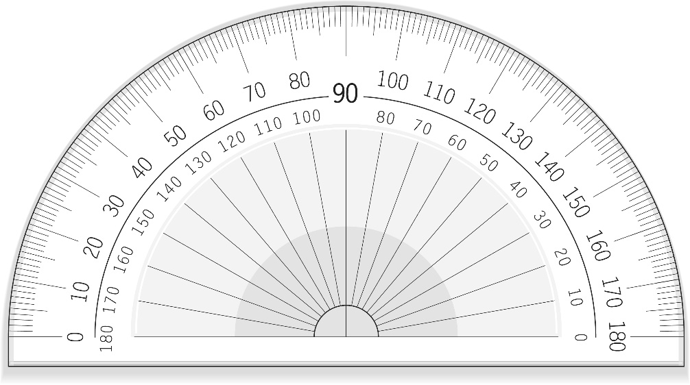

(shutterstock_146377604)

**This is 50 degrees**

**Always read from zero,**

**not 180.**



(shutterstock_146377604)

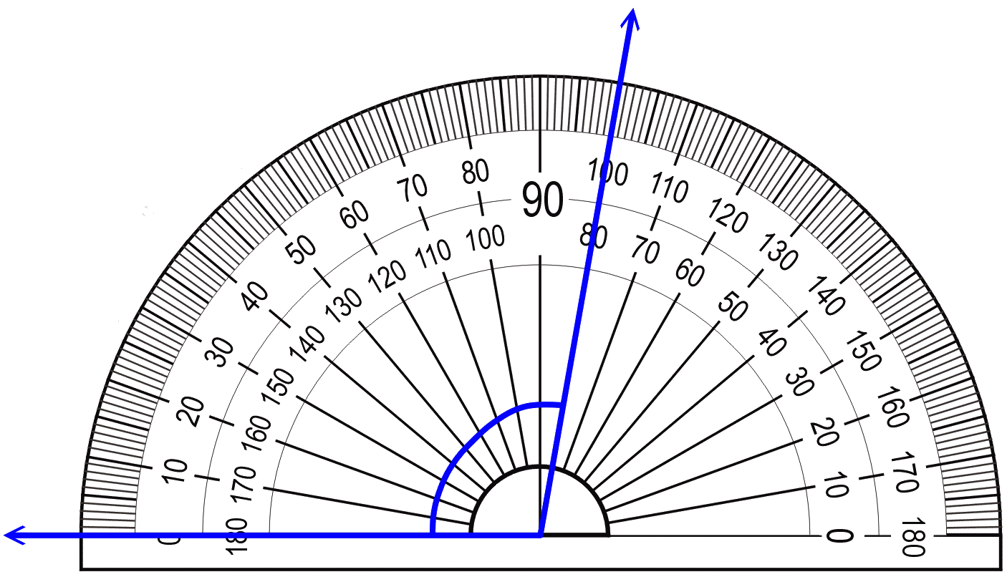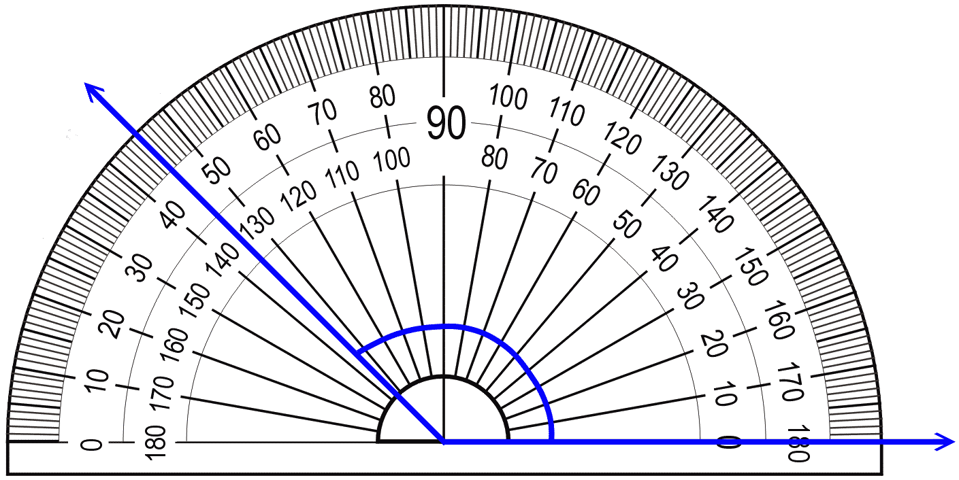 **Mean**

The "**mean**" is the "average" - you add up all the numbers and then divide by the number of numbers.

**Calculate the mean by adding all the numbers in the set of data and then dividing the total by how many numbers you have.**

**Example:**

In this data set we have six numbers

7 45 33 4 12 25

Added together = 126

Then divide by 6 (because there are 6 numbers) = 21

**The mean of these numbers is 21**

**Median**

The "**median**" is the "middle" value in the list of numbers.

**Calculate the median by ordering the numbers from smallest to largest and identifying the middle number**

**Example:**

Here is my original data collected about house numbers:

11 77 18 43 33 59 27

Now I must order the data from smallest to largest

11 18 27 33 43 59 77

The number in the middle is 33.

**Therefore, the median is 33.**

**BUT….What if there is an even number of numbers?**

For example, here is my data collected about house numbers.

11 77 18 43 33 59

Now I must order the data from smallest to largest

11 18 33 43 59 77

33 and 43 are both the middle numbers.

To calculate the median we need to take the mean of these two values (add them together and divide by 2).

33 + 43 = 76

76 ÷ 2 = 38

**The median is 38**

**Mode**

The **mode** is the number that is repeated the most

**To calculate the mode we need to count how many times each number occurs.**

For example, here is my data collected about ages of students.

17 17 16 18 19 18 19 17 21 23

17 occurs three times in this set of data, more than any other number.

The mode is 17.

*Note – sometimes there will be more than one mode.

**Range**

The **range** is the difference between the highest and lowest number in the data set

**To calculate the range we identify the largest number in the data set and subtract the smallest number in the data set.**

For example, here is my data collected about ages of students in our CGEA class.

17 17 16 18 19 18 19 17 21 23

The largest number in the data set is 23

The smallest number in the data set is 16

23 – 16 = 7

**The range of this data is 7**

**Ratio and Rates**

A ratio is a comparison of two numbers. We generally separate the two numbers in the ratio with a colon (:).

If we want to write the ratio of 8 and 12. We can write this as 8:12 and we say the ratio is *eight to twelve*.

**Example:**

In her school bag Jane has 4 markers and 7 books

What is the ratio of books to markers - Two ways of writing the ratio are 7 to 4, and 7:4.

What is the ratio of markers to the total number of items in the bag?  
There are 4 markers, and 4 + 7 = 11 items in total. The answer can be expressed as 4/11, 4 to 11 or 4:11

**Remember to be careful! Order matters!  
A ratio of 4:11 is not the same as a ratio of 11:4**

**Simplifying Ratios**

Problems are often made easier by putting the ration into their simplest terms.

The ratio 1 : 3, 3 : 7 and 9 : 4 are in their simplest terms because there is no number which will divide exactly into both sides.

The ratio 8 : 6 is not in its simplest terms because 2 will divide into both sides to give 4 : 3 which is the same as 8 : 6.

**Another example**

Put the ratio 72 : 84 in its simplest terms.

12 divides into 72 and 84, hence

72 : 84 is the same as

72 ÷ 12 : 84 ÷ 12. That is 72 : 84 is the same as 6 : 7

**Measures of Rate**

A **rate** is a ratio that expresses how long it takes to do something, such as travelling a certain distance.

**Examples:**

To walk 3 kilometres in one hour is to walk at the rate of 3 km/h.

If a car travels 10 km on 1 litre of fuel we say its fuel consumption is 10 km per litre of petrol. This is the rate at which the car consumes fuel.

The flow of water from a tap is usually measured in litres per minute. This is the rate of flow of the water.

**Indices, Powers and Roots**

**Indices** are a useful way of expressing large numbers in a simple way.

**Powers**, are a way of indicating that a quantity is to be multiplied by itself some number of times. In the expression 25, 2 is called the base and 5 is called the exponent, or power. 25 is shorthand for "multiply five twos together": 25 = 2×2×2×2×2 = 32.

The **root** of a number is another number, which when multiplied equals the given number. For example the second root of 9 is 3, because 3x3 = 9. The second root is usually called the square root

**Here is some helpful language:**

1. a x b can be written as ab

2. 5 x m can be written as 5m

3. P x p is the same as pp which is the same as p²

4. 3 x 3 is the same as writing 3²

5. 3² is read as “3 to the power of 2” or “3 squared.”

6. n³ is read as “n to the power of 3” or “n cubed.”

*ab*

base power

base power or index

7.

8. *54* means the base (*5*) is multiplied by itself 4 times

*54 = 5 x 5 x 5 x 5*

9. *t7* means the base (*t*) is multiplied by itself 7 times.

*t7 = *

10. *81 = 8* which also means, of course, that *8 = 81*

*a1 = a* which also means, of course, that *a = a1*

**Algebra**

Algebra is about finding the unknown or putting real life variables into equations and then solving them

**LIKE terms are terms with have EXACTLY the same letters. It doesn’t matter if they are in a different order and it doesn’t matter if the coefficients (numbers) are different.**

**Examples:**  2*e* and -5*e* and -2*e* are **LIKE** terms

-7*ab* and 12*ab* are **LIKE** terms

5*y* and 5*z* and 5*yz* are **UNLIKE** TERMS

2*abc* and 2*bcd* and -2*ab* are **UNLIKE** TERMS

**Adding and subtracting like terms**

In algebra, expressions can often be simplified. We can add or subtract LIKE terms.

*a + a + a + b + b*

*= 3a + 2b* (can’t go any further because 3a and 2b are UNLIKE terms.)

**Changing the Subject of Formula**

**Formula** means the relationship between two or more variables

**Subject of a formula** means the variable on its own, usually on the left hand side of the equals sign.

**Changing the subject of formula** means to rearrange the formula so that a different variable is on its own.

Imagine a formula to be like an onion, to re-arrange it you need to remove each layer from the variable you want to be left as the subject.

* **The order in which you do this is important. Generally, start at the outside of the formula and work your way in.**
* **Just like solving any other equation, when you move anything across the equals sign you must invert its operation.**

**For a visual example log onto the Internet and watch this video by Sarah Chammings https://www.youtube.com/watch?v=cbKc_qilgzA (or go to Youtube and type ‘Sarah Chammings How to change the subject of a formula’**

**Example 1, make the subject of the formula**

Here, is on the outside of the equation.

To ‘peel this away’ I need to undo it by inverting its operation

I will subtract from both sides

Now is on its own and therefore the subject of the formula

**Example 2 Make the subject of the formula**

is on the outside. Let’s add to both sides

is attached to the 2 with a multiplication.

Lets invert that operation and divide both sides by 2

Now is the subject of the formula

**Example 3 Make the subject of the formula**

The right hand side is divided by 5

So, lets multiply both sides by 5

Now is the subject of the formula

**Expanding and Simplifying and Substitution into Equations**

Expanding means that you need to remove or expand the brackets

**Examples**

Expand these expressions:

|  |  |
| --- | --- |
| 3 ( *x* - 6 )  Remember there is an invisible multiplication sign here.  ×  3 ( *x* - 6 )  = 3*x* - 18 | -3(*m* + 2)  When there is a NEGATIVE number outside the bracket, the signs INSIDE the bracket changes.  = -3*m* – 6 |

**Here are more guidelines for algebra:**

**LAW 1**

When multiplying terms with the SAME base, ADD the indices.

***am  an = a m+n***

**Example 1**

a3 x a2 = a x a x a x a x a= a5

**Example 2**

4a3 x 5a2 = 4 x a x a x a x 5 x a x a x a = 20a5

**Example 3**

104 x 102 = 106

(base is 10 base is 10 base is still 10)

**LAW 2**

When **dividing** terms with the **SAME** base, **subtract** the indices

***am  an = a m - n***

**Example 1**



1

1

1

1

1

1

Can you see a shortcut from here to here?

**Example 2**

(a) 

**Example 3**

(b) 

**Example 4**

(c)  =  =  = 

**Example 5**

(d) 

**LAW 3**

When there is one index raised to another index, multiply the two index numbers.

***(am)n = a m  n = a mn***

**Example 1**



Can you see a shortcut from here to here?

**Example 2**



Can you see a shortcut from here to here?

**Example 3**



**Example 4**

(a) 

Every term (in this case, the 4 and the ) inside the bracket is affected by the index outside the bracket.

**Example 5**



**Example 6**

( ) = 



**Example 7**

(d) 

**LAW 4**

Any term raised to the power of zero is equal to 1.

***a0 = 1***

**Example 1**

These two answers must be equal to each other.

Therefore, it follows that:

30 = 1



**Example 2**



These two answers must be equal to each other.

Therefore, it follows that:

Y0 =1



**Example 3**

1. 2b0  = 2 × b0  = 2 × 1 = 2 (Here, only the b is raised to the power of zero)
2. –12m0  = –12 × m0  = –12 × 1 = –12
3. (5h) 0  = 1
4. 5(h) 0 = 5 × 1 = 5
5. 4a0 – 1 = 4 × a0 – 1 = 4 × 1 – 1 = 4 – 1 =3
6. (7d2k5)0 + 1 = 1 + 1 = 2
7. 7(d2k5)0 + 1 = 7 ×(d2k5)0 + 1 = 7× 1 + 1 = 7 + 1 = 8

**LAW 5**

If a negative power is on the numerator, put it to the denominator and change it to positive.



Also, if a negative power is on the denominator, put it to the numerator and change it to positive.



**Example 1**



These two answers must be equal to each other.

Therefore, it follows that:



1

1

1

1

1

1



These two answers must be equal to each other.

Therefore, it follows that:



**Example** **2**



1

1

1

1

1

1

1

1

*

It is a mathematical convention to give answers with **positive** indices wherever possible.

**Example 3**

Write the following with positive indices and simplify wherever possible.

(a)  (b) 



(c)  (d) 

**LAW 6**

A number raised to a fraction index () represents the *nth*root of that number.



Remember square roots?

 and  etc..

Another way of writing square roots is with a fraction index



Like this: and

**Example 1**



**Example 2**

 (because 3×3×3=27)

**Example 3**



**Example 4**

 (because 2×2×2×2×2=32)

(Source: Original curriculum developed by Robyn McKenzie – Foundation College – April 2015)

**Useful Websites to practice your Literacy skills. These are all free access:**

**Highly recommended. This one contains interactive activities so you can check your answers:**

https://www.bbc.co.uk/education/subjects/zqhs34j

<https://www.mathsisfun.com/>

https://www.helpingwithmath.com

**For maths and numeracy reference:**

<http://www.schoolatoz.nsw.edu.au/homework-and-study/mathematics/help-sheets>

<https://www.khanacademy.org/math>

