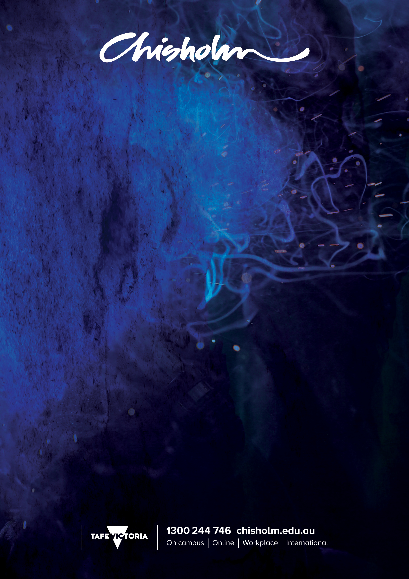

UET50219 Diploma of ESI – Power Systems
AUSTRALIAN QUALIFICATION

Course | UET 50219 – Diploma of ESI – Power Systems
Registered Training Organisation | Chisholm Institute  121 Stud Road  Dandenong, Victoria, Australia 3175  RTO Registration No. 260
Chisholm Course Coordinator | Philip Gallucci  Email: Philip.Gallucci@chisholm.edu.au
Entry Requirements | - Successful completion of Year 12  - Chisholm English Language Level IELTS 3.5
Course Duration | Three years consisting of:  - Year 1 - English Language development  - Years 2 and 3 - UET 50219 Diploma of ESI – Power Systems
Method of Delivery | The course is full time delivered in class for 25 hours per week over 40 weeks per year.
Course Overview | This course develops a range of high level skills in design, testing, repair and troubleshooting of electrical and electronic circuits, design and protection of distribution systems, management and implementation of environmental and sustainable systems in the electrical field.
Sample Units of Competency | The following units are an indication of units covered in the course:  - UEENEED104A - Use engineering applications software on personal computers  - UEENEEE101A - Apply occupational health and safety regulations, codes and practices in the workplace  - UEENEEE102A - Fabricate, assemble and dismantle utilities industry components  - UEENEEE104A - Solve problems in d.c. circuits  - UEENEEE105A - Fix and secure electrotechnology equipment  - UEENEEE107A - Use drawings, diagrams, schedules, standards, codes and specifications  - UEENEEE124A - Compile and produce an energy sector detailed report  - UEENEEE125A - Provide engineering solutions for problems in complex multiple path circuit  - UEENEEE126A - Provide solutions to basic engineering computational problems  - UEENEEG006A - Solve problems in single and three phase low voltage machines  - UEENEEG101A - Solve problems in electromagnetic devices and related circuits  - UEENEEG102A - Solve problems in low voltage a.c. circuits  - UEENEEG106A - Terminate cables, cords and accessories for low voltage circuits  - UEENEEG149A - Provide engineering solutions to problems in complex polyphase power circuits  - UEENEEH102A - Repairs basic electronic apparatus faults by replacement of components  - UEENEEH112A - Troubleshoot digital sub-systems  - UEENEEH139A - Troubleshoot basic amplifier circuits  - UEENEEI155A - Develop structured programs to control external devices  - UETTDREL11A - Apply sustainable energy and environmental procedures  - UETTDREL16A - Working safely near live electrical apparatus  - UETTDRIS62A - Implement and monitor the power system organisational OHS policies, procedures and programs  - UETTDRDS35A - Design overhead distribution power systems  - UETTDRDS39A - Prepare and manage detailed construction plans for electrical power system infrastructure  - UETTDRDS43A - Develop high voltage and low voltage distribution protection systems  - UETTDRIS63A - Implement & monitor the power system environmental & sustainable energy management policies & procedures  - UETTDRIS67A - Solve problems in energy supply network equipment  - UETTDRIS68A - Solve problems in energy supply network protection equipment and systems  - UETTDRTS28A - Repair, test and calibrate protection relays and meters
Chisholm’s Obligations to you | Students are enrolled at Chisholm and Chisholm’s Training Partner Institute. This means that Chisholm will be responsible for the quality of the training and assessment. It also means that students are covered by Chisholm policies in the event that the Training Partner Institute ceases delivery of this course.  Upon graduation students will be awarded:  - Chisholm Institute English Certificate  - Diploma of ESI – Power Systems ( UET50219)  - Aligned Diploma from your Training Partner Institute  Upon enrolment you will have access to:  - UET50219 Course Guide with information about the course, units, assessment, learning resources, policies and coordinator details  - A copy of the learning resources for the course such as textbooks, course workbooks manuals and any additional classroom handouts.  You will be advised by the Training Partner Institute of any additional materials and equipment that the student may need to provide for their training.
Grievances | Chisholm recognises that from time to time student grievances or complaints may occur on various matters.  The Chisholm Complaint Policy is designed to facilitate the equitable and speedy resolution of these grievances.  All students are entitled to fair and consistent treatment and prompt consideration and resolution of complaints. You can gain further information through your course coordinator or the Chisholm course coordinator.  See link below for Complaints and Appeals Policy
RPL | Chisholm has a policy to provide for the assessment and various types of learning undertaken by a student prior to enrolment at Chisholm.  This may include relevant work experience and other courses of study; this is known as Recognition of Prior Learning (RPL).  Students can gain further information from the Course Coordinators  See link below for RPL and Credit Transfer Policy
Chisholm Policies | Chisholm policies and procedures are available on the Institute Website:  https://qms.chisholm.edu.au  Some of the key policies relating to students are listed below:
- Assessment of Learning-Vocational Education & Training ( VET) | QMS 111
- Privacy and Freedom of Information | QMS 301
- Copyright and Intellectual Property | QMS 302
- Student Complaints and Appeals | QMS 306
- Student Code of Conduct | QMS 117
- RPL and Credit Transfer and Recognition of Current Competency | QMS 107

Pathways | When students complete their course at Chisholm, it opens the door to further study at either Chisholm or another Australian Institution.  In some cases graduates will be eligible for credit transfer into aligned university programs upon the successful completion of the Chisholm Diploma.  Students can gain further information from the Course Coordinator
Fees | Information on fees, payment terms and conditions and refund policy is available from the Training Partner Institute.

